# Question 1

## Task 1

**Visualization 1.1.1**

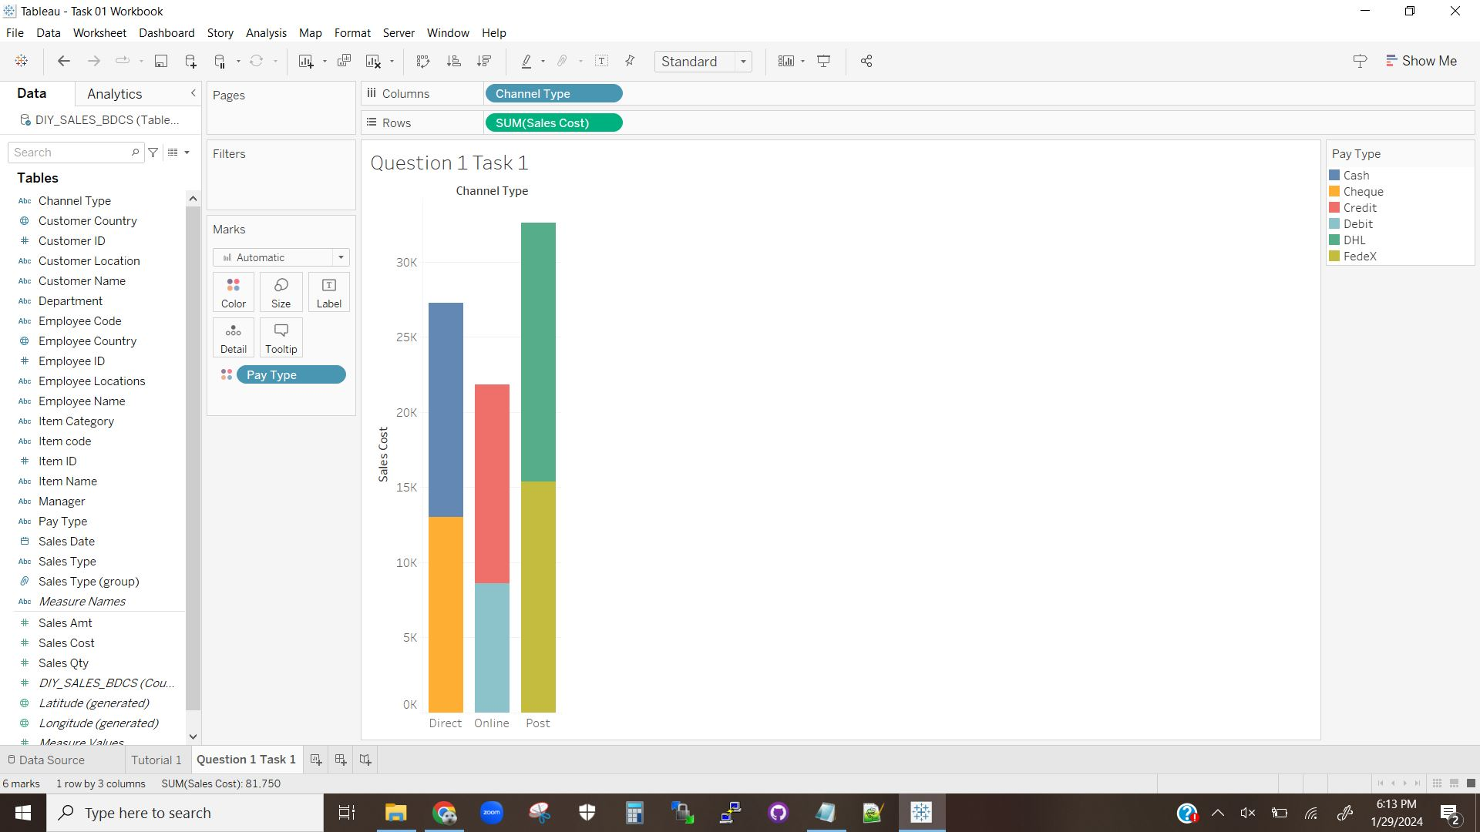

The above visualization is a stacked histogram of the sales costs based on channel type. The bars are further divided via color according to pay type, so that the viewer can see how much of each channel’s sales are in each of the pay categories. The colors are stacked as opposed to overlapping, so the colors are percentages of the whole view-wise (though the hard values are included).

**Visualization 1.1.2**

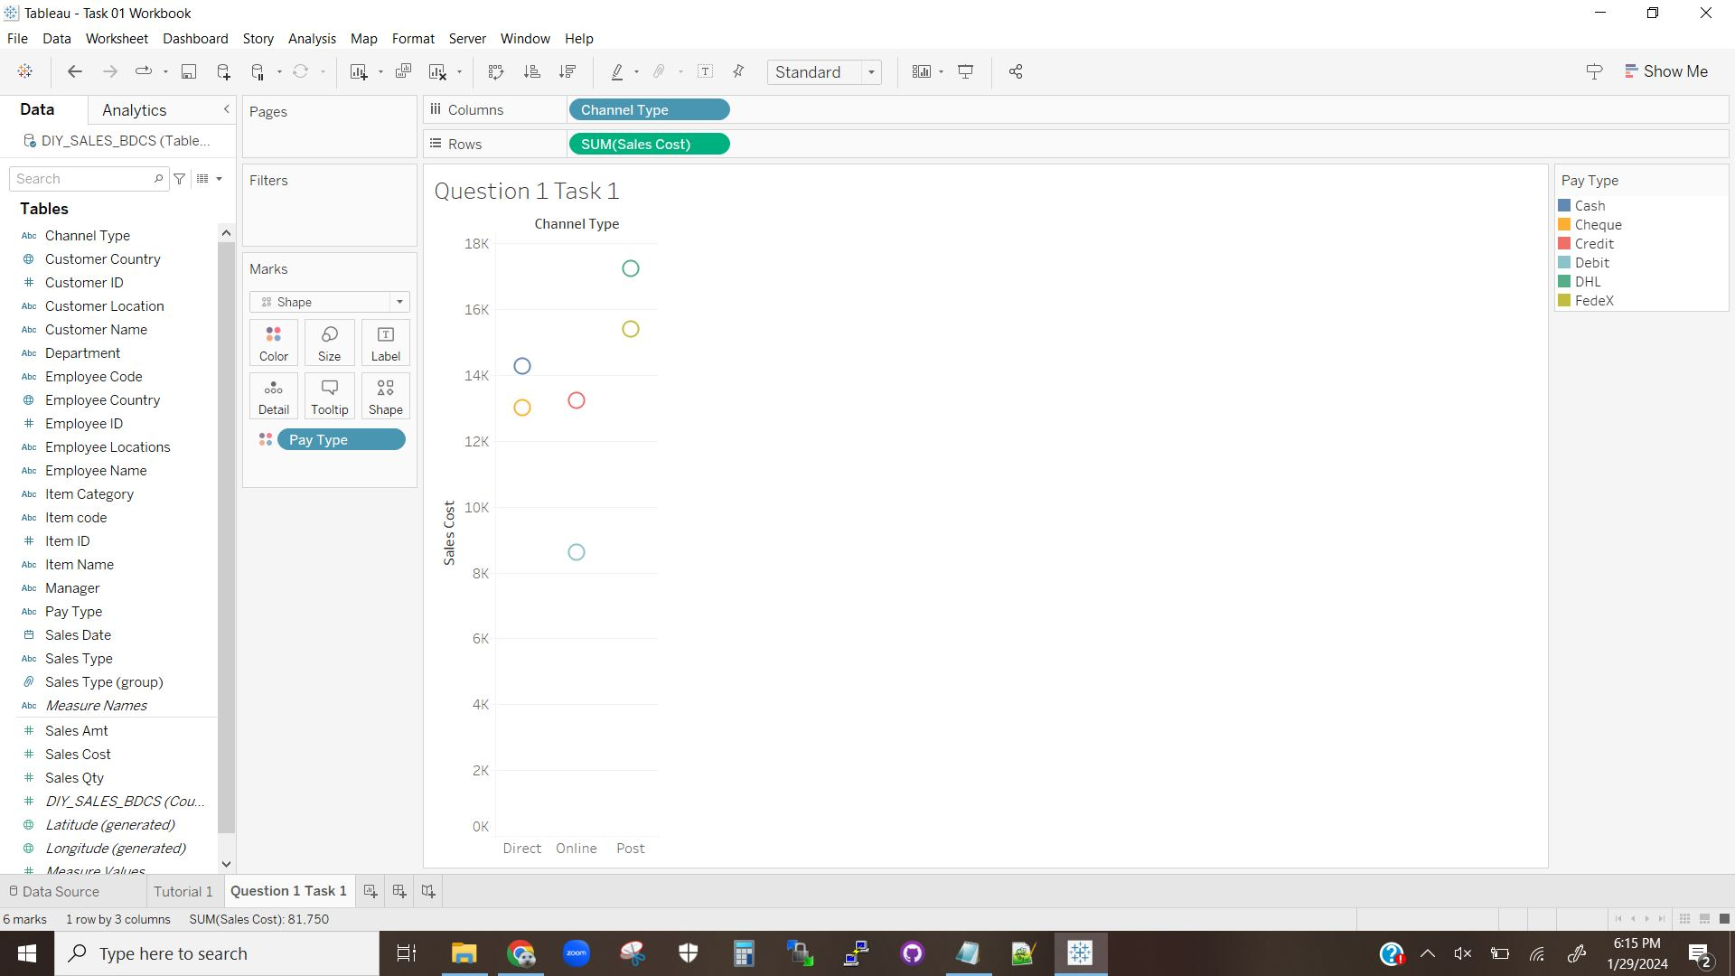

The above visualization is a circle view chart of the sales costs based on channel type. The circles are further grouped by color according to pay type. The circle chart is similar to the stacked histogram in visualization 1.1.1, however the final value is represented by a circle at the location as opposed to a bar running from the x-axis to that location. Additionally values within each channel according to pay type aren’t stacked, and therefore visually represent hard values as opposed to percentages of the whole.

## Task 2

**Visualization 1.2.1**

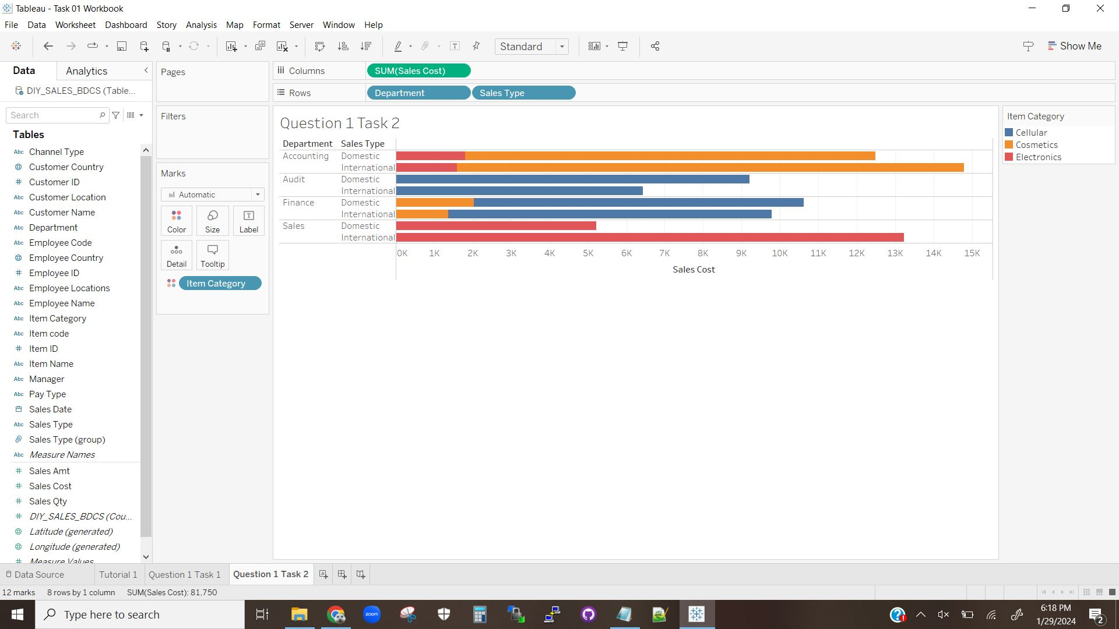

The above visualization is a stacked bar chart of sales costs by both department and sales type, further grouped by item category. As in visualization 1.1.1 the colors within a bar contain hard values, but represent the percentage of the whole bar value for each category in item category. This graph further groups values by directly comparing the sales type within each department via placing the bars next to each other.

**Visualization 1.2.2**

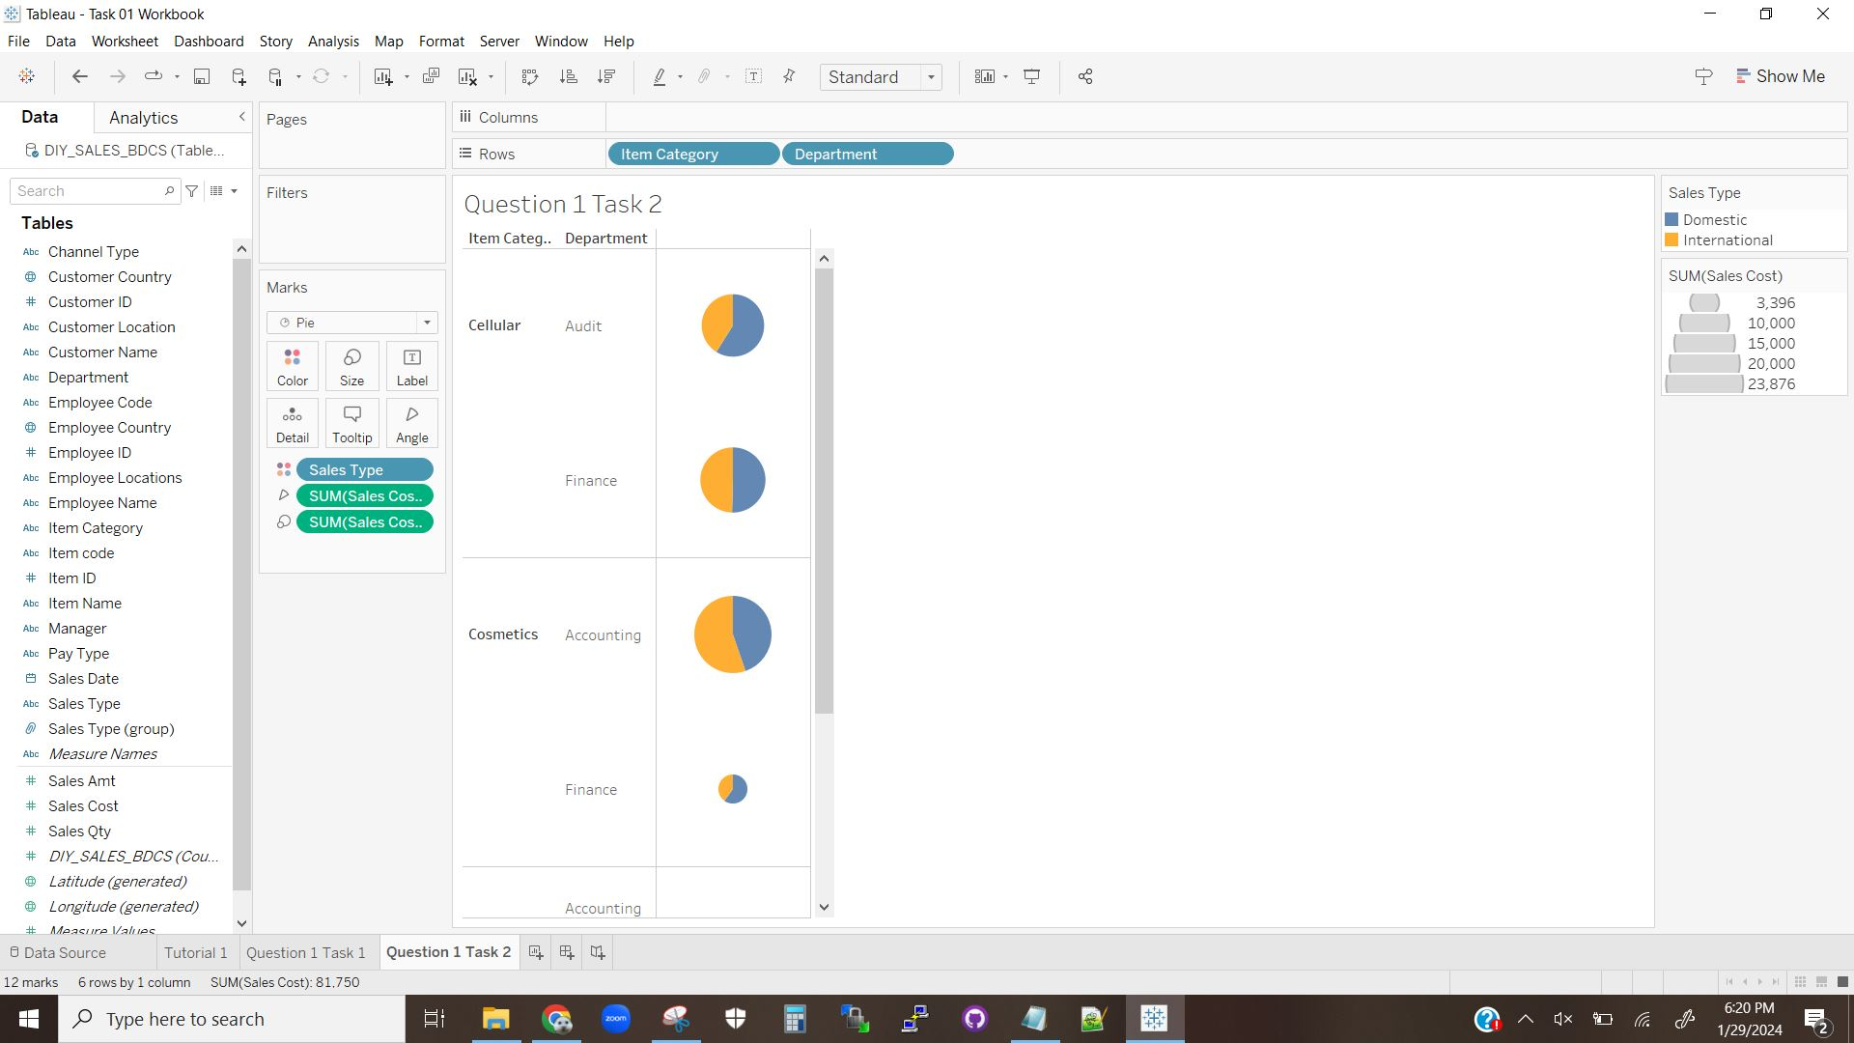

The above visualization is a collection of pie charts representing the data for this task. Each color in each pie chart represents the percentage that each sales type contributes to the total for that item category and department. Additionally the relative sizes of each pie chart represent the percentage of the total that the respective departments contributed to the sales for each item category.

**Visualization 1.2.3**

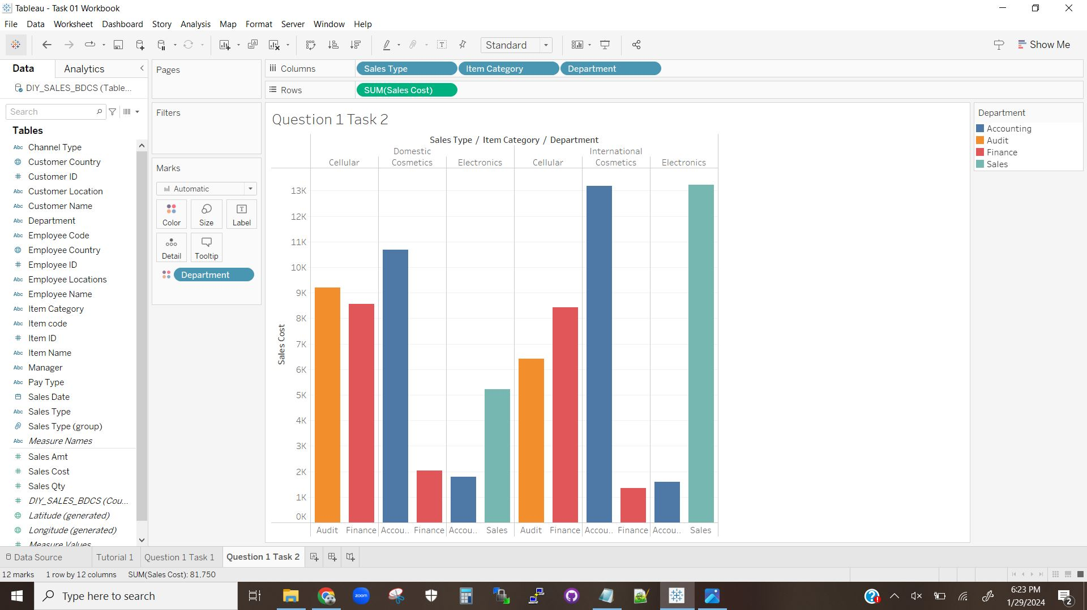

The above visualization is a histogram that sorts the sales costs according to the groupings of sales type, item category, and department. The parent/child categories are defined by the order of the columns in the entry bar. Additionally the bars are colored by department to allow for easier comparison of the bars when they’re scattered across the graph. This coloring is the most useful if the column ordering is arranged such that the department columns are as distributed as possible across the chart.

# Question 2

**Visualization 2.1**

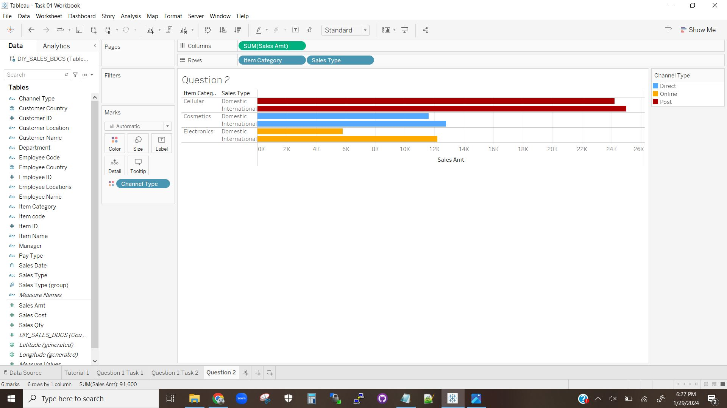

The above visualization is a bar chart showing the sales amounts according to item category and sales type. The different colors represent the different categories of channel type.

and shows them to be matched to the different item categories.

**Visualization 2.2**

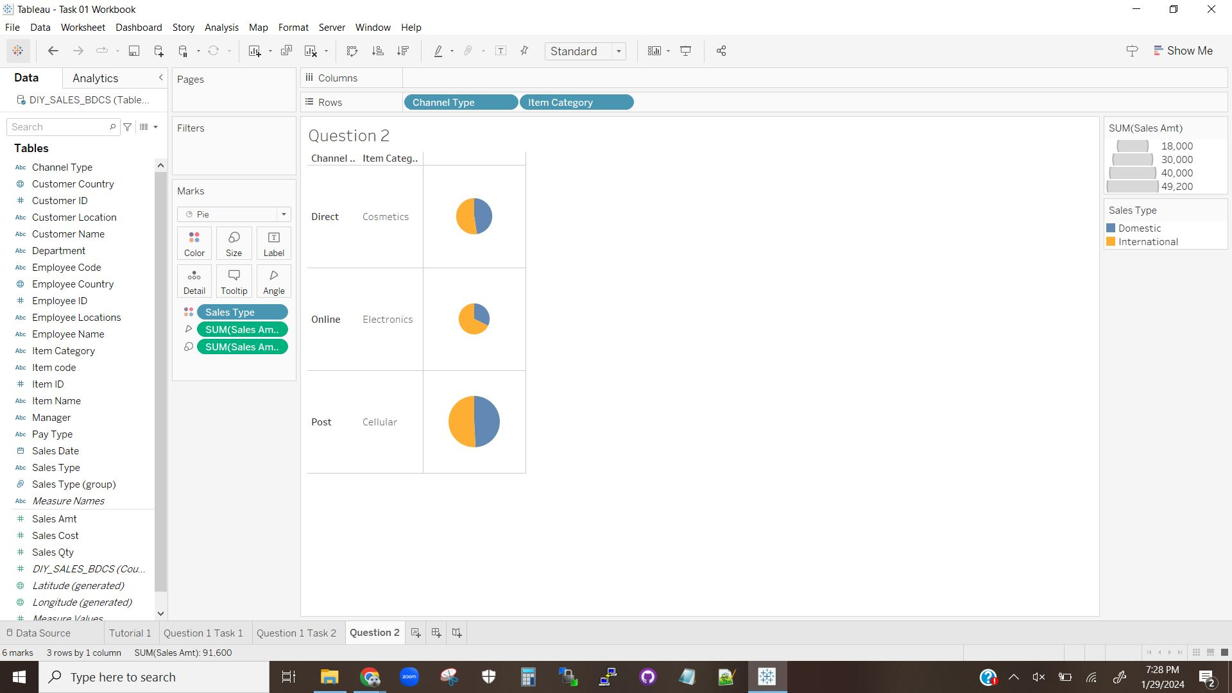

The above visualization is a collection of pie charts showing the relative contributions of sales amounts based on channel type, item category, and sales type. The relative contributions to each channel type and item category based on sales type is represented by the color, while the relative contributions between the channel types and item categories is represented by the size of each pie chart.

# Activity Explanation

This activity was an introduction to the usage of Tableau. The tutorials walk students through how to group and arrange attributes on a chart, how to select chart types, and how to modify colors for added depth to each graph. By requiring multiple visualizations for each question the activity teaches students to explore how to arrange the same features for each type of chart and encourages them to explore Tableau’s capabilities. By asking for explanations/descriptions of each chart the activity encourages students to think about the carts they are constructing and ask themselves if the charts they made are appropriate for the data, if the charts make sense, and consider what each chart is telling them about the data. Overall this activity is a basic introduction to how to load data into Tableau and how to work with it, and does not not overwhelm the students with many new tools and capabilities and lets them get to the core of what Tableau does. This activity and its paired tutorials provide a basic guide that manages to, at the same time, display some of Tableau’s best capabilities and best uses while also hinting at some of the tools that would unlock Tableau’s full potential.